**Name: Victoria Jacqueline Macías Pico**

**W O R K S H E E T S**

**NOTE:** **Your answers must be in blue and bold.**

# UNIT 12

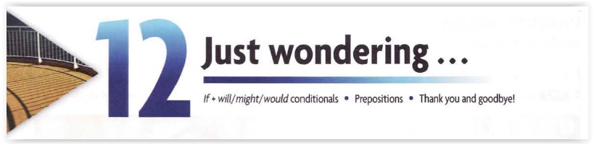

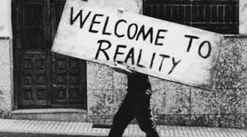**FIRST CONDITIONAL**

1. **Complete the chart:**

|  |  |  |  |  |  |
| --- | --- | --- | --- | --- | --- |
| STRUCTURE |  |  |  |  |  |
|  | *If clause* | *,* | *main clause (simple future)* | | |
| if | it is sunny | , | we will go for a picnic. | | |
| If | We get sick | , | we won’t go out. | | |
| If | You come with me | , | we might have lunch together. | | |

**What if we change the order …?**

|  |  |  |
| --- | --- | --- |
| I will go for a picnic | if | It is sunny. |
| We won´t go | If | We get sick. |
| We might have lunch together | if | You come with me. |

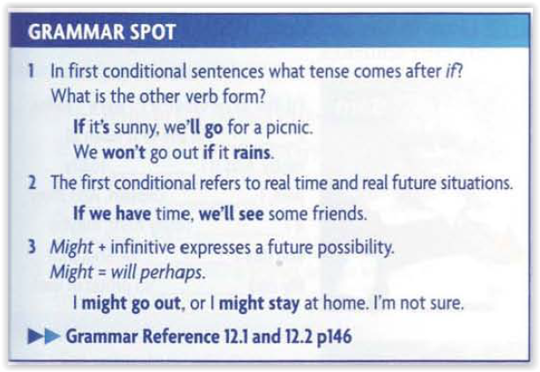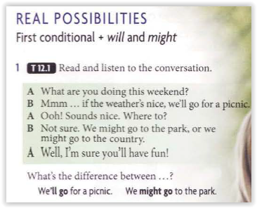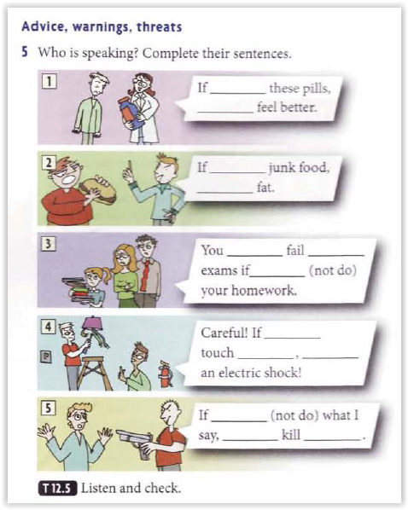

**You take**

**You will**

**You eat**

**You will get**

**will**

**the**

**You don’t do**

**You**

**You**

**That**

**You will get**

**You will get**

**You Don’t do**

**I will**

**you**

**2. Complete with the correct form of the verb. FIRST CONDITIONAL.**

1. If you  **don’t hurry**  (not/hurry), we will be late!
2. If Camila  **passes**  (pass) her exam, she will be very happy.
3. However, if Camila fails, she  **won’t be**  (not be) very happy.
4. If you stay awake all night, you  **will be**  (be) very tired tomorrow.
5. Enrique  **won’t win**  (not \ win) the lottery if he doesn't buy a ticket.

**3. Complete the sentences with the correct form of the verbs. FIRST CONDITIONAL.**

1. If we  **send**  (send) an invitation, our friends  **will come**  (come) to our party.
2. He  **won’t understand**  (not understand) you if you  **whisper**  (whisper).
3. They  **won’t survive**  (not survive) in the desert if they  **don’t bring**  (not bring) water.
4. If you  **press**  (press) CTRL + s, you  **will save**  (save) the file.
5. I  **will remember**  (remember) you if you  **give**  (give) me a photo.

**SECOND CONDITIONAL**

1. **Complete the chart:**

|  |  |  |  |  |  |
| --- | --- | --- | --- | --- | --- |
| STRUCTURE |  |  |  |  |  |
|  | *If clause* | *,* | *main clause* | | |
| if | I won the lottery | , | I would go to the Maldives. | | |
| If | I could fly | , | I would go to Istanbul. | | |
| If | I were a mermaid | , | I would be very happy. | | |

**What if we change the order …?**

|  |  |  |
| --- | --- | --- |
| I would go to the Maldives | if | I won the lottery. |
| I’d go to Istanbul | if | I could fly. |
| I’d would be very happy | if | I were a mermaid. |

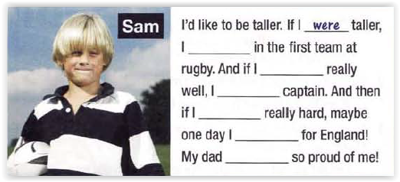

**‘d be**

**played**

**‘d be**

**Practiced**

**practiced**

**Could play**

**Would be**

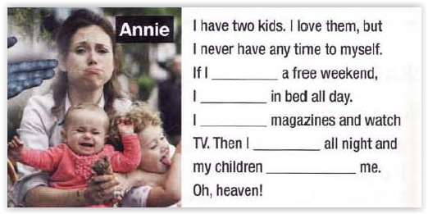

**Had a**

**‘d stay**

**‘d stay**

**‘d read**

**‘d sleep**

**‘d sleep**

**Wouldn’t wake**

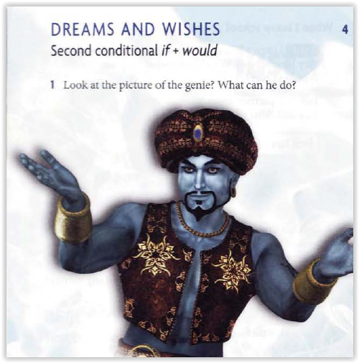

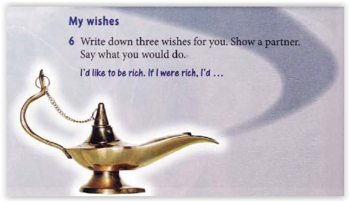

|  |  |
| --- | --- |
| **If I were rich,** | **I´d buy a house.** |
| If I were rich, | **I’d help people in need.** |
| If I were rich, | **I’d buy many shoes.** |

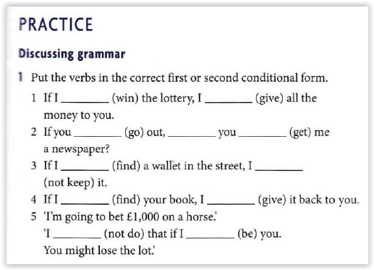

**won**

**Would give**

**will**

**go**

**Wouldn’t keep**

**get**

**found**

**find**

**Will give**

**Wouldn’t do**

**were**

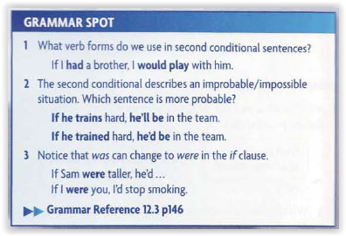

1. **Complete the chart with sentences of your own.**

|  |  |  |  |
| --- | --- | --- | --- |
| **STRUCTURE** |  | |  |
| **If I …** | **were** | **the president,** | **I’d change the current laws.** |
| **had** | **a lot of money,** | **I’d travel all over the world.** |
| **didn’t know** | **the time,** | **I’d stay with you all day.** |

**3. Complete the sentences with the correct form of the verbs. SECOND CONDITIONAL.**

1. If Alessandro  **sold**  (sell) his old mobile, he **would buy**  (buy) a new laptop.
2. We  **would come**  (come) to the party if it  **started**  (start) at 8 o'clock.
3. The boy  **would be**  (to be) on the Olympic team if he  **trained**  (train) harder.
4. What  **would**  you do if there  **were**  (to be) an earthquake?
5. If you  **clicked**  (click) the red button, you  **would cancel**  (cancel) the download.

**4. Complete the sentences with the correct form of the verbs. SECOND CONDITIONAL.**

1. If you  **used**  (to use) a pencil, the drawing  **would be**  (to be) perfect.
2. The children  **would be**  (to be) happy if he  **taught**  (to teach) them English.
3. If Irene  **visited**  (to visit) us, we  **would go**  (to go) out tonight.
4. They  **would come**  (to come) again if he  **planned**  (to plan) a second stay.
5. If you  **dropped**  (to drop) this bottle, it  **wouldn’t break**  (not/to break).

**5. Differences between the 1rst and 2nd Conditional tenses?**

|  |  |  |
| --- | --- | --- |
|  | **1rst Conditional** | **2nd Conditional** |
| **Structure** | **If+simple present+simple future** | **If+past simple+would+Verb infinitive** |
|  | **Will** | **Would**  **Was turns into were (advice)** |
|  | **Posibilities** |  |
|  | **Real events** | **Unreal events** |

**Conditionals game:** <https://www.gamestolearnenglish.com/conditional-sentences/>

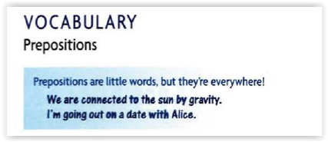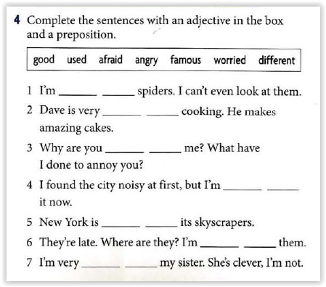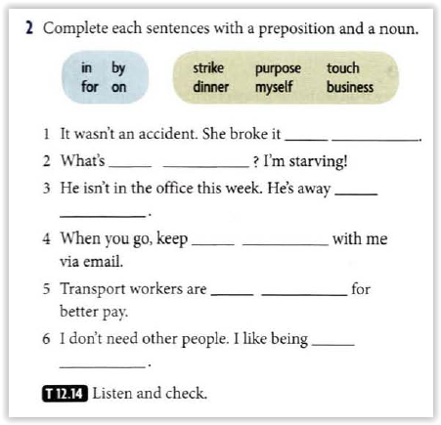

**On purpose**

**For dinner**

**I touch**

**On strike**

**By myself**

**On business**

**Afraid of**

**Good at**

**Angry with**

**Used to**

**Famous for**

**Worried about**

**Different from**